Photography Service Website

Submitted By:
Hassam Jamil , Rohan Zulfiqar ,Abubaker
2025-CS-72,2025-CS-63,2025-CS-73
Submitted To:
Sir Moazzam
Department of Computer Science
University of Engineering and Technology, Lahore.

1. Introduction
In today’s digital era, websites play a crucial role in showcasing services and portfolios. Photography businesses especially rely on visually appealing websites to present their work, attract clients, and communicate professionally.
This project focuses on the development of a Photography Services Website using HTML and CSS for the frontend, a theoretical database design using SQL, basic Canva designs for branding, and GitHub for version control and project hosting. The website allows visitors to explore photography albums, learn about services, and contact the photographer.

2. Objectives
The main objectives of this project are:
- To design a professional photography website using HTML and CSS
- To understand frontend website structure and styling
- To design a basic relational database theoretically
- To practice SQL queries (CRUD operations)
- To create simple visual designs using Canva
- To upload and manage the project using GitHub
- To document the complete work in a structured manner

3. Tools Used
The following tools and technologies were used in this project:

Frontend Development
- HTML5
- CSS3

Database (Theoretical)
- SQL (Structured Query Language)

Design Tool
- Canva (Basic)

Version Control
- Git
- GitHub

Editor
- Visual Studio Code

4. Website Pages Explanation

4.1 Home Page
The Home page is the main landing page of the website. It includes:
- Navigation bar (Home, About, Contact)
- Brand name and slogan
- Slideshow showcasing photography images
- Call-to-action button to explore albums
- Album slider displaying different photography categories such as:
  - Wedding
  - Nature
  - Wildlife
  - Architecture
  - Events
  - Culture
This page is designed to create a strong first impression.
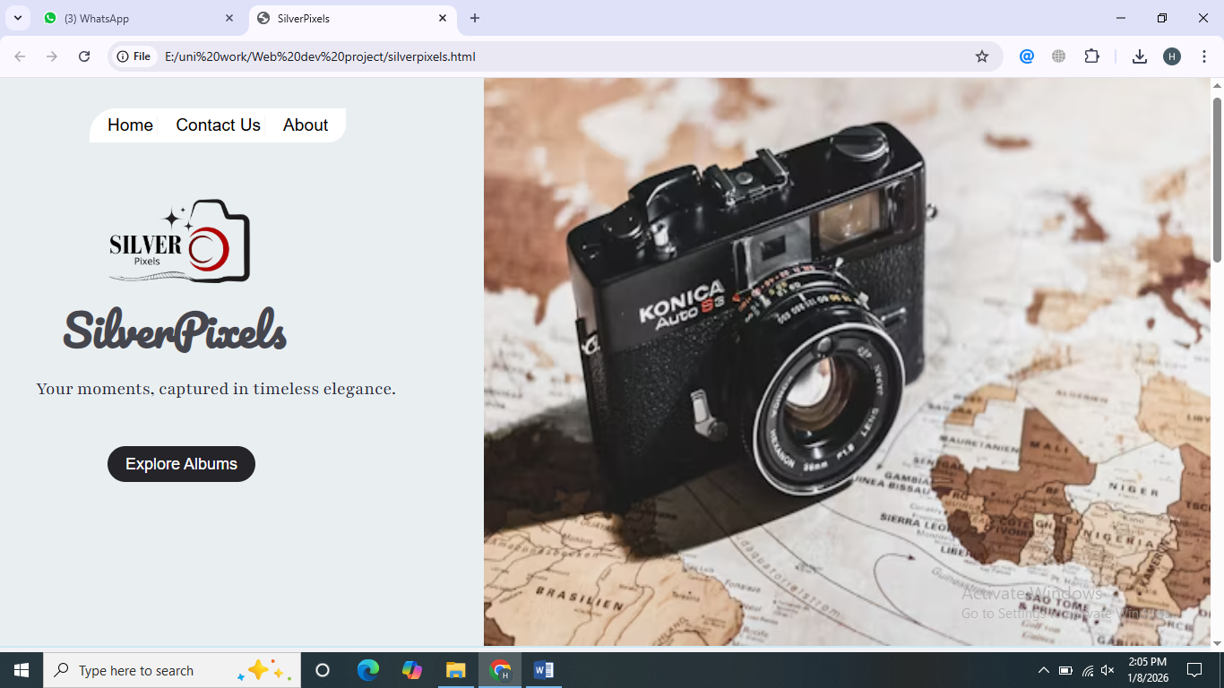

4.2 About Page
The About section explains:
- The purpose of the photography studio
- The vision and creativity behind the brand
- Experience and photography genres
- Statistics such as years of experience and happy clients
This page builds trust and credibility with visitors.
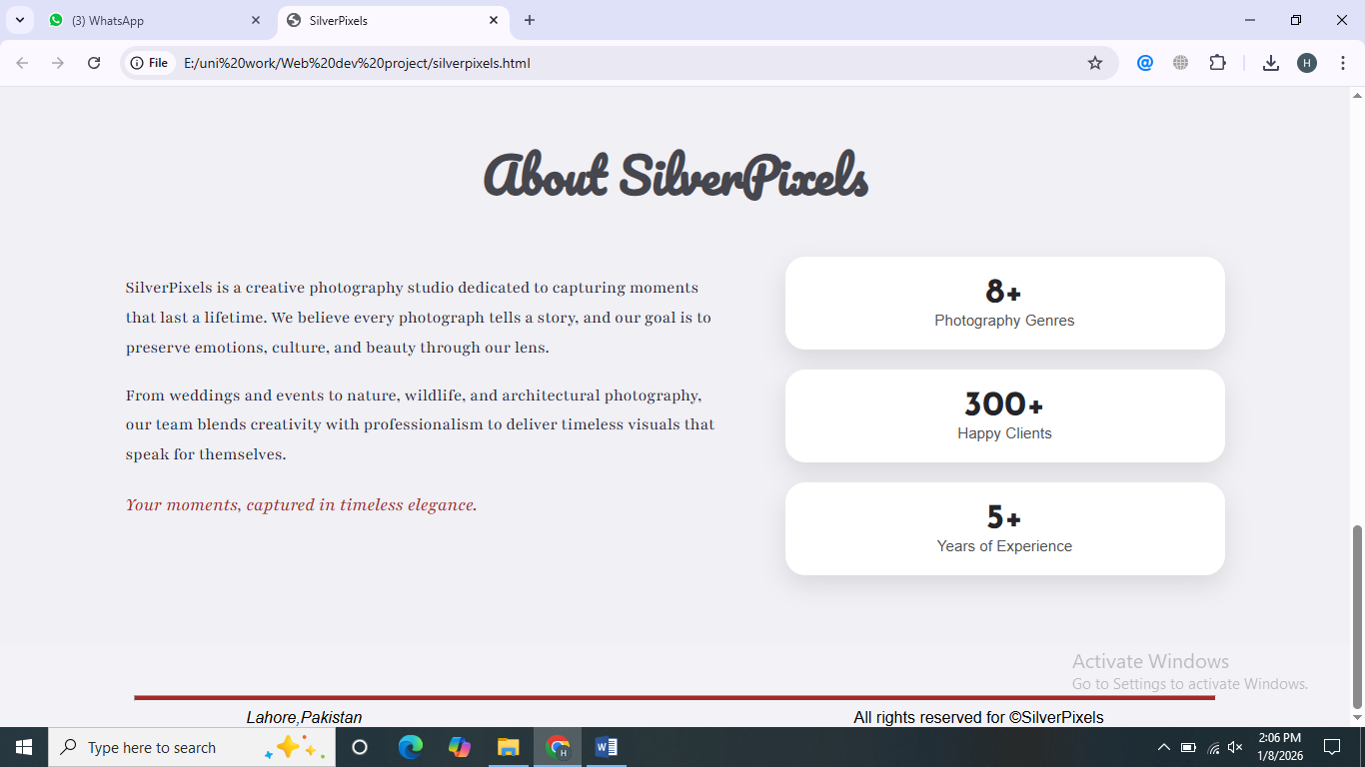

4.3 Services / Features
Services are displayed in the form of albums, representing different photography categories. Each album includes:
- Cover image
- Title
- Short description
- View album button
This helps users understand the range of photography services offered.
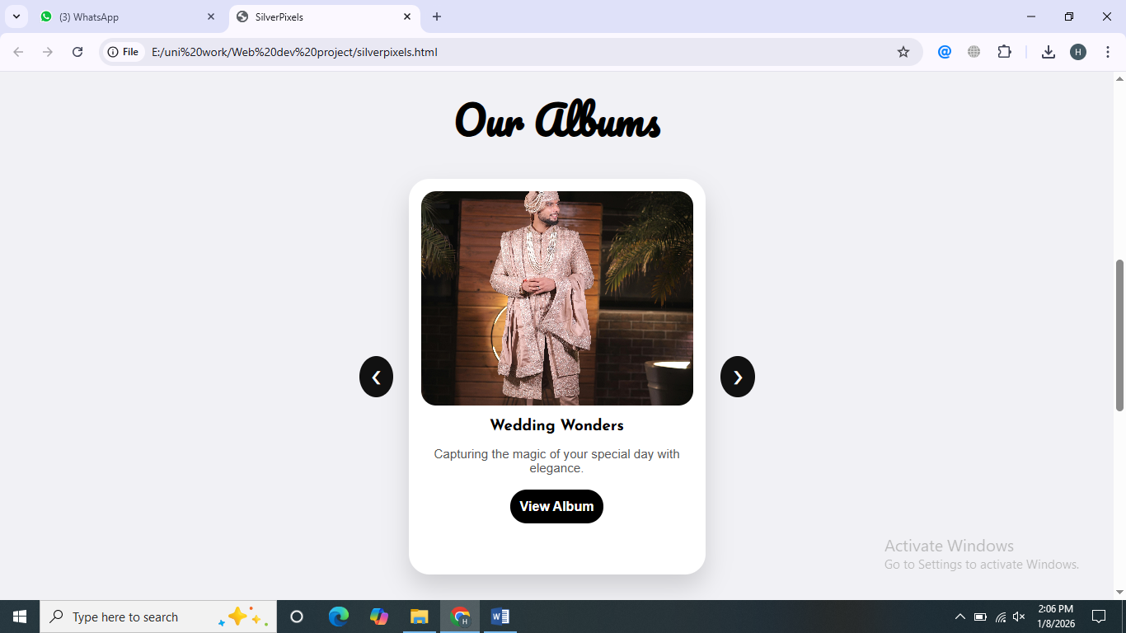

4.4 Contact Page
The Contact page contains a form where users can:
- Enter their name
- Provide email address
- Write a message
This page allows visitors to communicate directly with the photographer.
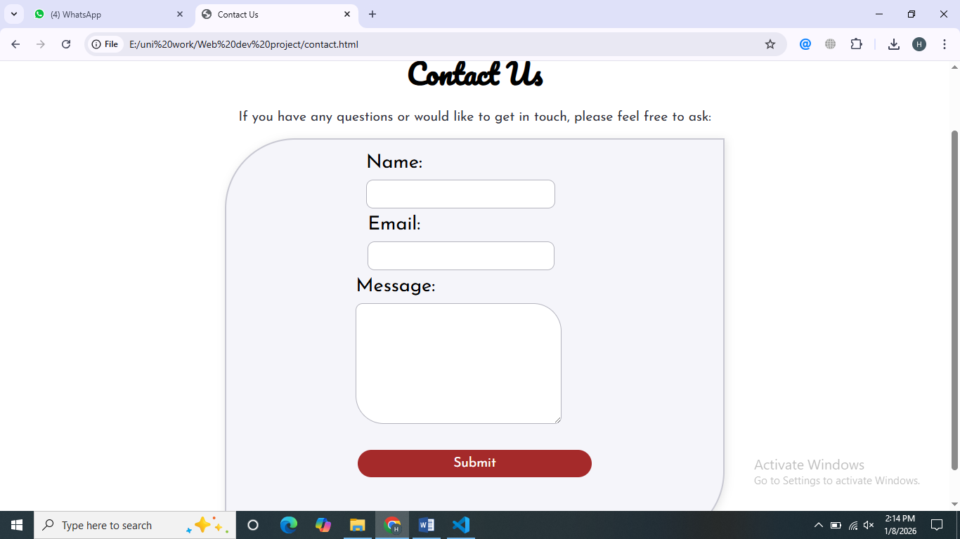

5. Database Design (Theoretical)
The database is designed theoretically to support the website functionality.
Minimum three tables are used.

5.1 Table: Users
Stores information about the website administrator.

6. SQL Queries (Theoretical)

6.1 CREATE TABLE
Used to create tables in the database.
CREATE TABLE clients (
client_id INT AUTO_INCREMENT PRIMARY KEY,
name VARCHAR(80) NOT NULL,
email VARCHAR(100) UNIQUE NOT NULL,
phone VARCHAR(15),
created_at TIMESTAMP DEFAULT CURRENT_TIMESTAMP
) ENGINE=InnoDB;
CREATE TABLE packages (
package_id INT AUTO_INCREMENT PRIMARY KEY,
title VARCHAR(100) NOT NULL,
description TEXT,
price DECIMAL(10,2) NOT NULL,
duration_hours INT DEFAULT 2,
is_active BOOLEAN DEFAULT TRUE
) ENGINE=InnoDB;
CREATE TABLE bookings (
booking_id INT AUTO_INCREMENT PRIMARY KEY,
client_id INT NOT NULL,
package_id INT NOT NULL,
shoot_date DATE NOT NULL,
notes TEXT,
status ENUM('confirmed', 'pending', 'completed', 'canceled') DEFAULT 'pending',
created_at TIMESTAMP DEFAULT CURRENT_TIMESTAMP,
FOREIGN KEY (client_id) REFERENCES clients(client_id),
FOREIGN KEY (package_id) REFERENCES packages(package_id)
) ENGINE=InnoDB;

6.2 INSERT
Used to insert data into tables.
INSERT INTO clients (name, email, phone) VALUES
('Alice Johnson', 'alice@example.com', '+923001234567'),
('Bob Smith', 'bob@example.com', '+923009876543'),
('Cathy Lee', 'cathy@example.com', '+923005555555');

INSERT INTO packages (title, description, price, duration_hours) VALUES
('Wedding Package', 'Full-day wedding coverage, 10 edited photos', 999.00, 8),
('Family Portrait', '1-hour session, 5 high-res photos', 199.00, 1),
('Event Coverage', '3-hour corporate event, 20 edited photos', 499.00, 3);

INSERT INTO bookings (client_id, package_id, shoot_date, notes, status) VALUES
(1, 1, '2026-06-15', 'Golden hour preferred', 'confirmed'),
(2, 3, '2026-07-01', 'Corporate event in Lahore', 'pending'),
(3, 2, '2026-05-20', 'Outdoor family shoot', 'completed');

6.3 SELECT
Used to retrieve data.
-- 3. SELECT — Show affordable packages
SELECT * FROM packages WHERE price < 500; -- All affordable packages

6.4 UPDATE
Used to update existing records.
-- 4. UPDATE — Confirm a booking
UPDATE bookings
SET status = 'confirmed', notes = 'Client confirmed via WhatsApp'
WHERE booking_id = 1;

6.5 DELETE
Used to delete records.
-- 5. DELETE — Remove a package only if unused
DELETE FROM packages
WHERE package_id = 2
AND NOT EXISTS (SELECT 1 FROM bookings WHERE package_id = 2);
-- (Note: This may fail if bookings exist — safe guard clause)

7. Canva Designs
The following designs were created using Canva:
- Website Banner:
Used for branding and homepage visuals

- Logo:
Designed for the photography brand identity

- Poster / Social Media Post:
Used for promotion on social platforms
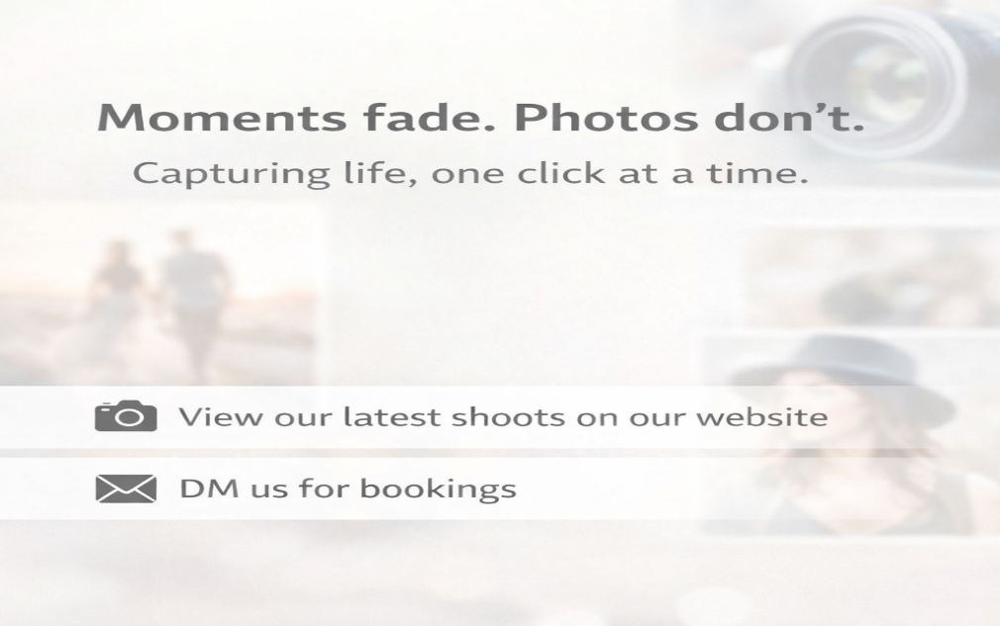
These designs enhance visual appeal and branding.

8. GitHub Repository
The complete project is uploaded on GitHub.
GitHub Repository Link:
https://github.com/hassamjamildesign/Web-dev-project
second member is added as collaborator.
GitHub was used for:
- Version control
- Backup
- Project submission

9. Conclusion
This project successfully demonstrates the development of a Photography Services Website using frontend technologies, theoretical database design, basic graphic design, and version control. It improved understanding of website structure, styling, database concepts, and professional project documentation.
The project can be further enhanced by:
- Adding backend functionality
- Implementing real database integration
- Adding user authentication
- Improving responsiveness

